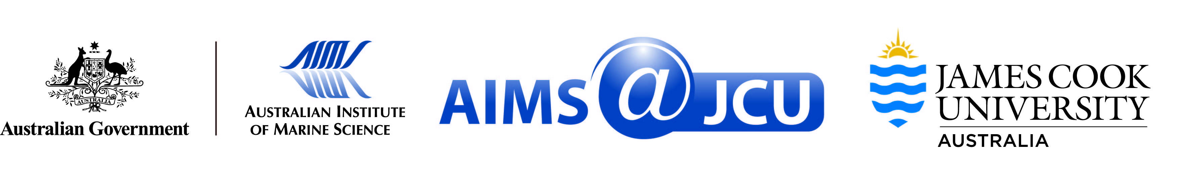

AIMS@JCU Professional Development Award Guidelines

AIMS@JCU Professional Development funding awards will be distributed on a competitive basis and are subject to several criteria. Students will be assessed on the quality of their proposed professional development plan.

This award is to be used for training.

- Formal training at an institute, workplace or in industry to learn a new skill or technique
- Work experience to develop your skill set

Eligibility:
- AIMS@JCU student member at any level
- Confirmation of supervisor support
- All documentation to be received by AIMS@JCU by 24th September 2023
- Only one award can be applied for per event

To apply:
Please create one pdf document containing:
- A completed application form
- A professional development plan (i.e. a statement indicating how the funds will be used, not to exceed 250 words)
- Letters of support from supervisors at both parent institutions
- Curriculum vitae

AIMS@JCU Professional Development Award Application Form

Name:
College:
What degree you are enrolled in:
Start year of your degree:
Expected completion date:

Workshop/Course:
Location of travel:
Dates of travel (if applicable):

Primary JCU Supervisor:
Primary AIMS Supervisor:
Additional supervisors (include institution):

Details of request:
Amount of funding requested: $................
(Maximum of $750 for an activity within Australia;
maximum of $1,500 for an activity outside of Australia)
On a separate page please outline how funds will be used in your proposed Professional Development plan (not to exceed 250 words)

Required attachments combined into one pdf document:
Completed application form
Professional Development plan
Letter of support from JCU supervisor
Letter of support from AIMS supervisor
Curriculum vitae

Applicant Signature:

Date:

